A285-Asia-Harappa-Zebu Bull-Pipal Tree-Gazelles-Terracotta-2600–1900 BCE

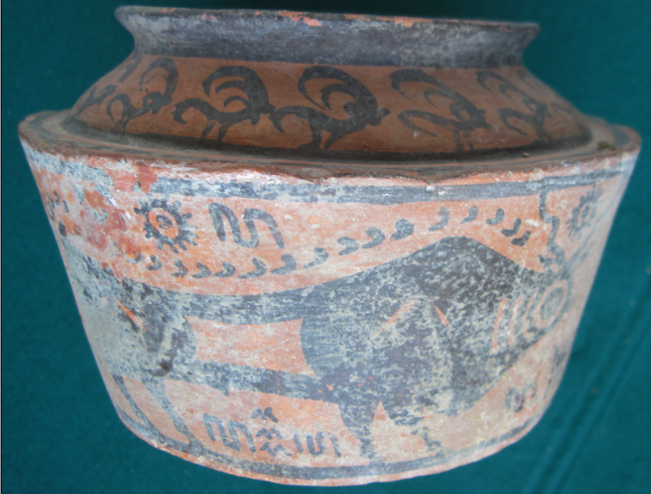 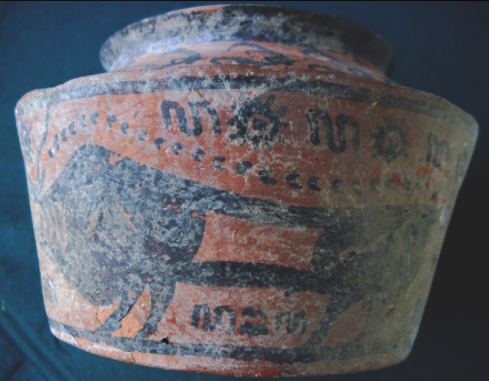

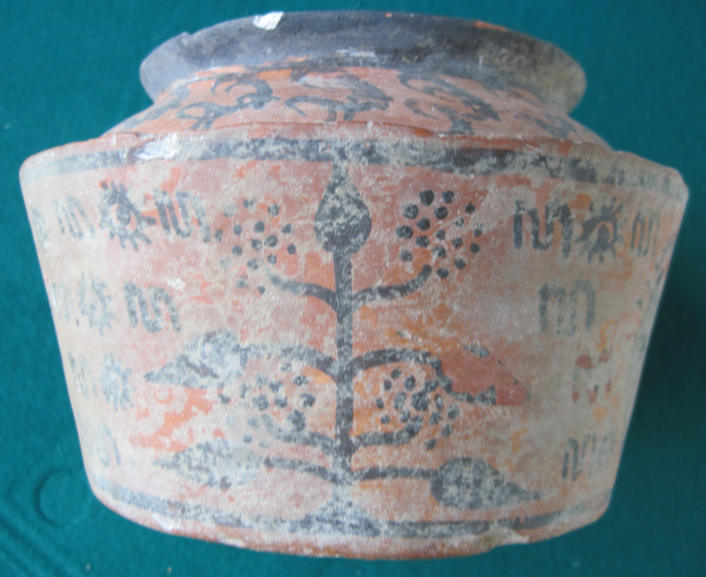 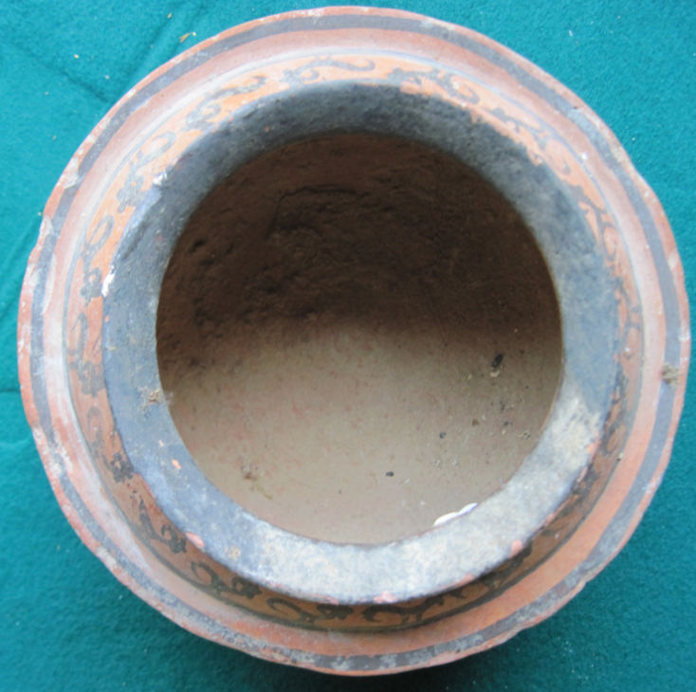

Figs. 1-4. Harappa-Zebu Bull-Pipal Tree-Gazelles-Terracotta-2600–1900 BCE

**Case no.: 3**

**Accession Number: A284**

**Formal Label:** Harappa-Zebu Bull-Pipal Tree-Gazelles-Terracotta-2600–1900 BCE

**Display Description:**

This third millennium BCE Harappa terracotta combines symbolism of the zebu bull, the pipal tree (*Jicus religiosa*), gazelles, water and migrating birds. Zebu cattle were important in Harappa’s agrarian economy, and the zebu bull assumed a rôle as the symbol of fertility and fruitfulness.

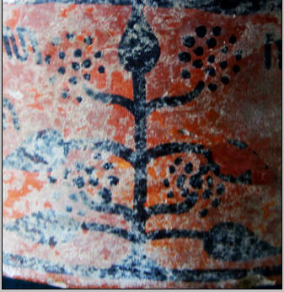 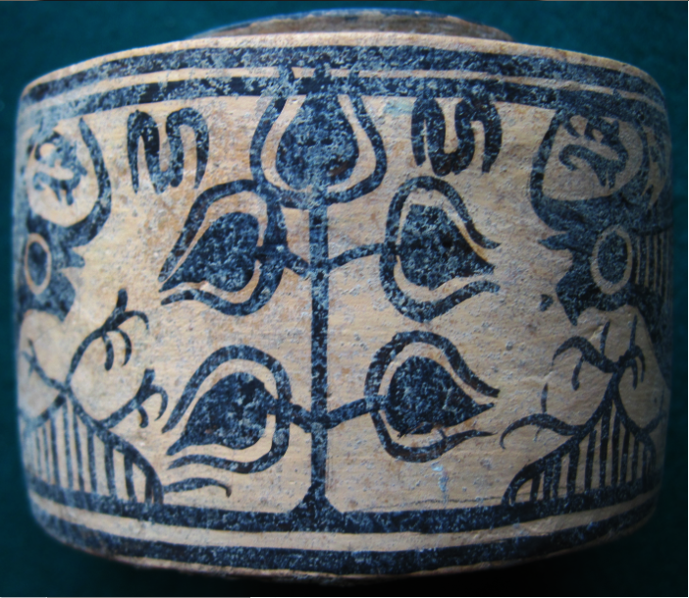

Figs. 5-6. The pipal tree assumed its rôle as a symbol of the fruit of enlightenment.

The vertical structure of the tree also suggests it stands for the successive enlightenment chackras.



Fig. 7. Gazelle symbolism around the rim suggests Vayu, a primary Hindu deity, lord of the winds.

“The other atmospheric gods are his associates: Vayu-Vatah, Parjanya, the Rudras and the Maruts. All of them are fighters and destroyers, they are powerful and heroic” (Bhattacharji 1984). He is also father of Bhima and the spiritual father of Hanuman. He is also known as Anil ("Air, Wind"), Vyān (Air), Vāta ("Airy Element"), Tanun (The Wind), Pavan ("Purifier"), and Prāṇa ("Breath"). All these associations suggest a spiritual element to be achieved (Raju 1954).

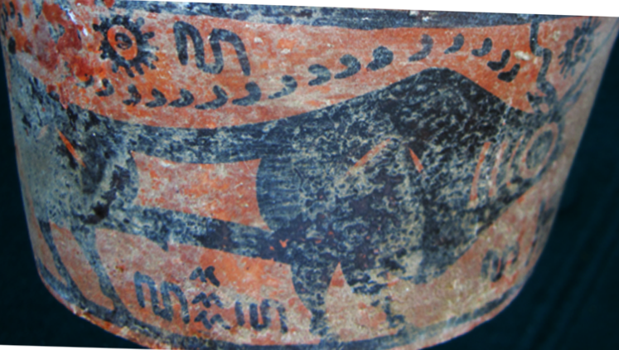

Fig. 8. The zebu bull’s image suggests the method by which Harappa pastoralists may have identified their domesticated cattle.

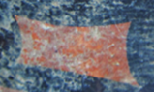

Fig. 9. Possible tribal marking.



Fig. 10. Couplet of symbols suggests sun and water.



Fig. 11. The bull’s ungulate tracks may indicate its migratory route which was to be followed.



Fig. 12. A triplet suggesting “water-- birds migrating--water,” which may indicate a location where the zebu bulls were to be found, “by the waters to which birds migrate”.

These are the oldest glyphs we have for the Harappa civilization, and they represent a more coherent text than do many of the steatite stamps. Ceramics, then, may provide a point of access to the glyphs and the syntax of the Harappan and Mohenjo Daro stamp seals.

**LC Classification:** DS486 H35  
**Date or Time Horizon:** 2600–1900 BCE

**Geographical Area:** Harappa

**Map, GPS coordinates:**

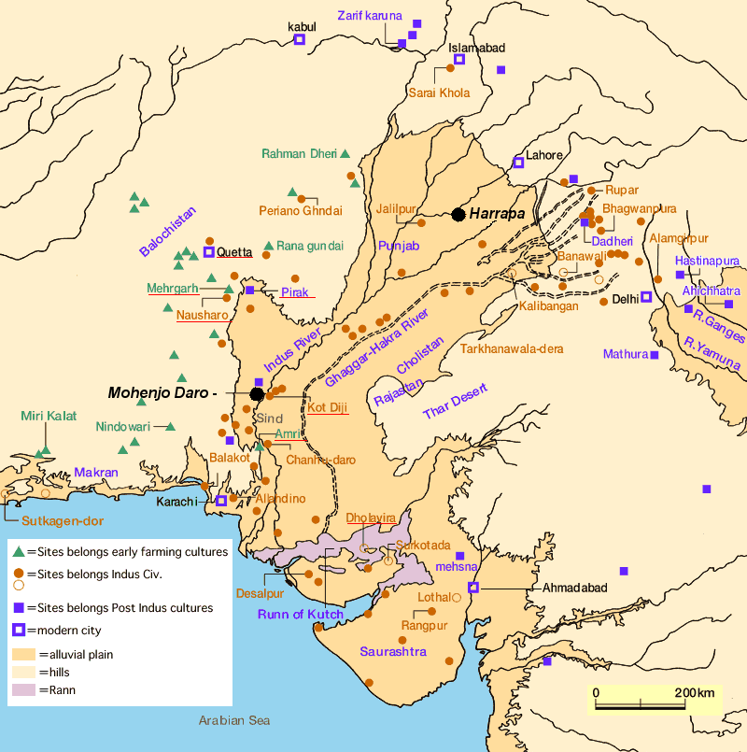

Fig. 13. Map of Indus sites from https://encrypted-tbn0.gstatic.com/images?q=tbn:ANd9GcSnoolUCyM4saSet1fqKCqzYEWJhfDBzJsATILKpXYgG8P2maLY.

**Map, GPS coordinates:** [27°19′45″N 68°08′20″E](https://tools.wmflabs.org/geohack/geohack.php?pagename=Mohenjo-daro&params=27_19_45_N_68_08_20_E_type:landmark)

**Cultural Affiliation:** Harappa

**Media:** Terracotta, black pigment

**Dimensions:**

**Weight:**

**Condition: original**

**Provenance:** unknown

**Discussion:**

Following the Harappan civilization’s decline, northwestern India was settled by Aryan-speaking peoples who were pastoral, and the economic importance of cattle is reflected in the ritual and symbolism of the Vedic literature of Hinduism. At this time-horizon 1900-1600 BCE, during the impact of Hindu influence, the pipal tree became the symbolic abode of the Hindu trinity of masculine deities: Shiva, Vishnu and Brahma.

**References:**

[Bhattacharji](https://www.google.com/search?tbo=p&tbm=bks&q=inauthor:%22Sukumari+Bhattacharji%22), Sukumari. 1984 *Literature in the Vedic Age:* *The Saṃhitās*. New Delhi: K.P. Bagchi.

Jansen, Eva Rudy; Tony Langham. 1993. *The book of Hindu imagery: The Gods and their Symbols*. New Delhi: Binkey Kok Publications.

Raju, P.T. 1954. “The concept of the spiritual in Indian thought,” *Philosophy East and West*, 4 (3): 195–213.

Ratnagar, Shereen. 1981. *Encounters, the westerly trade of the Harappa civilization*. Delh, New York: Oxford University Press.

Vats, Madho Sarup. 1999. *Excavations at Harappa: being an account of archaeological excavations at Harappa carried out between the years 1920-21 and 1933-34.* New Delhi: Director General, Archaeological Survey of India.